**Crime Trends in Austin Texas**

**Introduction**

Crime affects many people. Analyzing data related to a crime can reveal trends that can help reduce crime and help people avoid crime-prone situations. The data used for this project provides information for the city of Austin Texas in 2015. Several trends were identified in the data providing useful insights about crime in Austin texas.

**Dataset**

**Analysis technique**

In many cities, Some area are known as being dangerous and visitors are often discouraged from going to these areas. In order to answer questions about the rate of crime in different areas, two techniques were applied to this data set.

First, is there a relation between the number of crimes and the side of the city? All reports of crime were sorted in ascending order by the X Coordinate of that crime. These crimes were then separated into 100 bins based on their location and the number of crimes in each bin was counted. This process was done for the whole city and for each zip code.

Second, Which city districts have the highest rate of crime? To solve this question, the mean number of crimes per month was calculated for each district and displayed on a bar chart with error bars representing the standard deviation of each district’s monthly crime rate.

**Results**

Knowing which areas of the city are dangerous is important when deciding how to distribute police officers, where to live, and more. To help find more dangerous areas in Austin we have answered several questions related to the rate of crime and its location.

Is there a relation between the number of crimes and the side of the city?

Often some areas in a city are more dangerous than others. To see if the east side of the city has more crime and if the crime increases the farther east a person travels we counted the number of crime with respect toX Coordinate locations. This generated the following graph.

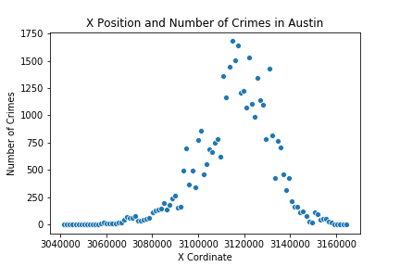

This graph indicate that the amount of crime increase toward the center of the city but does not indicate that the east side is more dangerous.

To see if this trend was true on a smaller level all zip codes were also individually checked. Some zip codes showed no correlation between x location an the number of crimes while others exhibited obvious patterns.

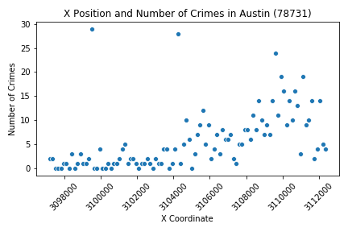

The zip code 78731 had a Pearson score of

0.54 with a p-value 7.1e-09. While this shows there is some trend. living on the west side might not mean people see more crime, because if the size or population increase with respect to the X-coordinate our result may be misleading.

Which district is the most dangerous?

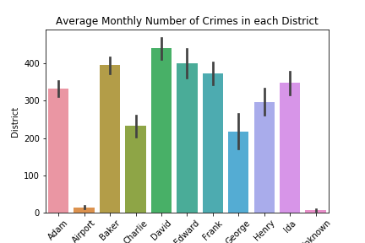

Austin is divided into nine districts and knowing which districts are the most dangerous can help provide insight into which areas of the city need more support. The following graph shows that the David district has the highest average monthly crime rate; however, the black bar indicating its standard deviation of the monthly crime rates shows that it is likely that several other districts could have similar crime rates.

Which month has the highest crime rates?

Burglary was highest in the month of December.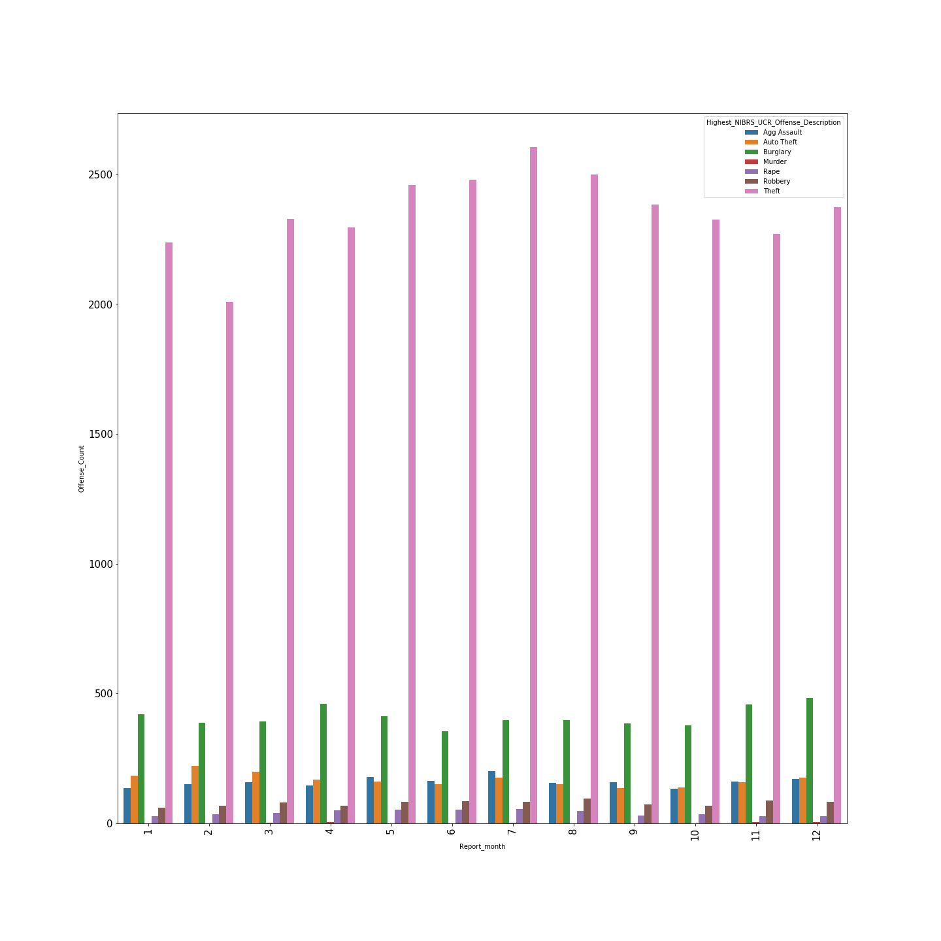

Theft was highest in the month of July.

Grouped data on report dates and then aggregated on count different types of crimes.

Correlation between Poverty level, Median Income , Unemployment and Offense Count.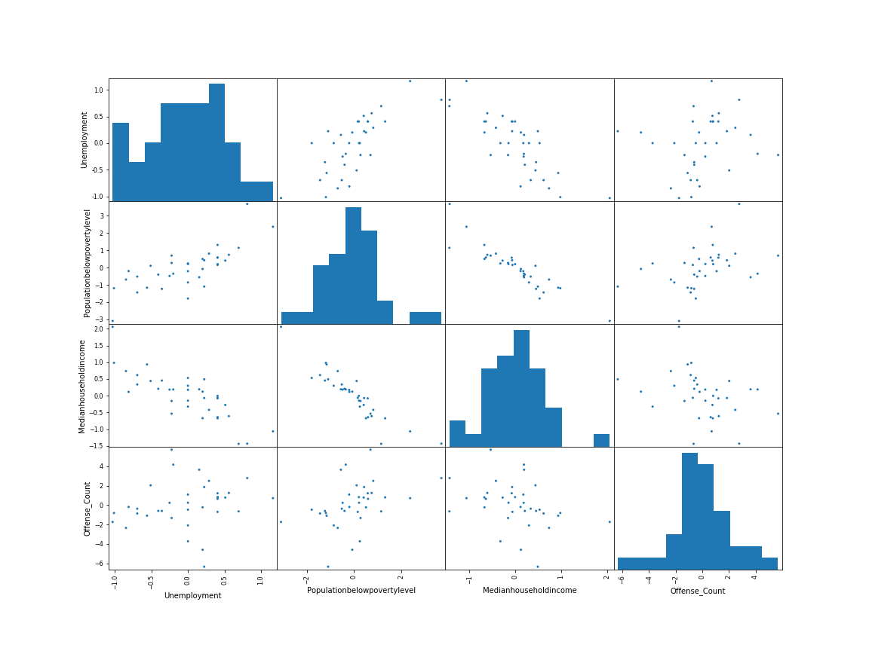

We tried to find if there is any good amount of correlation between poverty level and offense count. But found out that there was not a good amount of good relation. But there was a strong negative correlation between poverty level and median income.

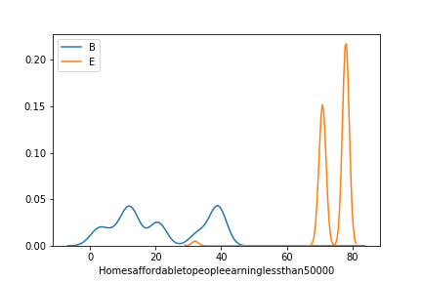

Ttest for Homes affordable for people earning less than 50,000$ in Baker and Edward dsitrict.

As the p-value is less than 0.05 we reject the null hypothesis that there's no difference between the means and conclude that a significant difference does exist.

Ttest for Rentals affordable for people earning less than 25,000$ in Baker and Edward district.As the p-value is greater than 0.05 we cannot conclude that a significant difference exists.